**Problem Statement**:

You work for XYZ Corporation. Your corporation is working on an application and they require secured web servers on Linux to launch the application.

**Tasks To Be Performed:**

1. Create an instance in the US-East-2 (Ohio) region with Linux OS and manage the requirement of web servers of your company using AMI.

2. Replicate the instance in the US-West-2 (Oregon) region.

3. Build two EBS volumes and attach them to the instance in the US-East-2 (Ohio) region.

4. Delete one volume after detaching it and extend the size of the other volume.

5. Take backup of this EBS volume

**Procedure:**

* First, we will launch an instance with the ubuntu machine. And connect the instance with cli and install the server that is apache2. Run the following commands.
* sudo apt-get update
* sudo apt-get install apache2 -y
* therefore, we have now installed the web server apache 2 into our machine.

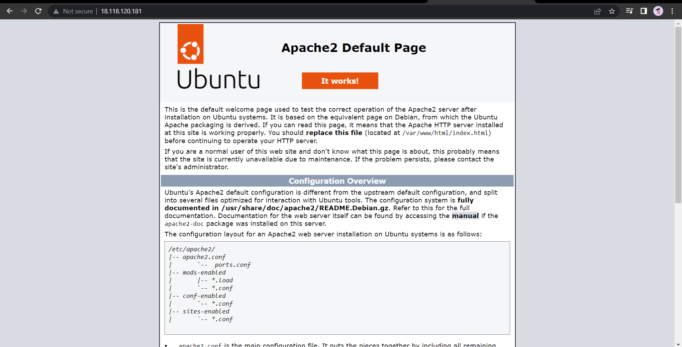

* 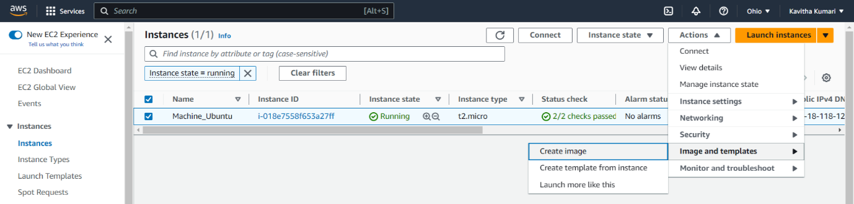Now we must replicate the region to the oregon region. For this first we will create the AMI of the existing machine and replicate that AMI to the Oregon region.
* Now give the name for AMI and click on create ami.
* 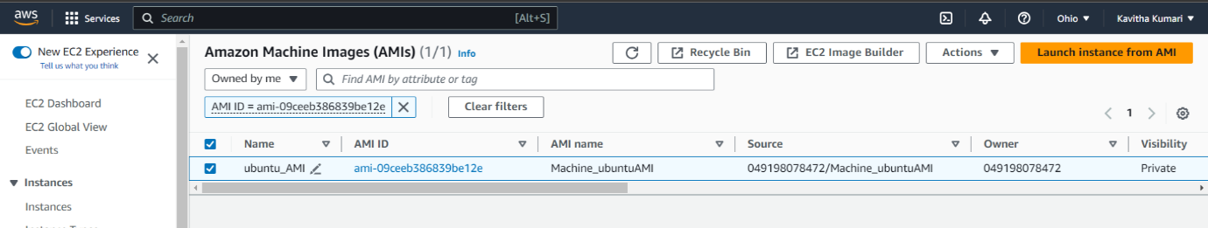Now we need to copy the AMI to the another region.

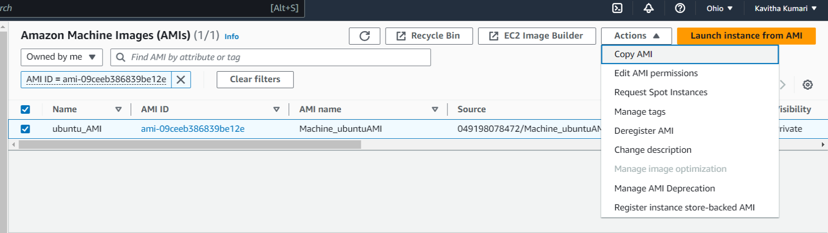

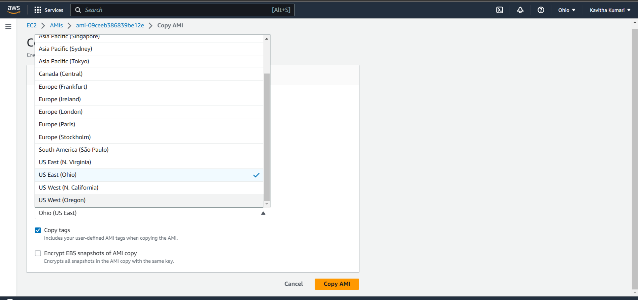

* Select the US West (Oregon) and click on Copy AMI.

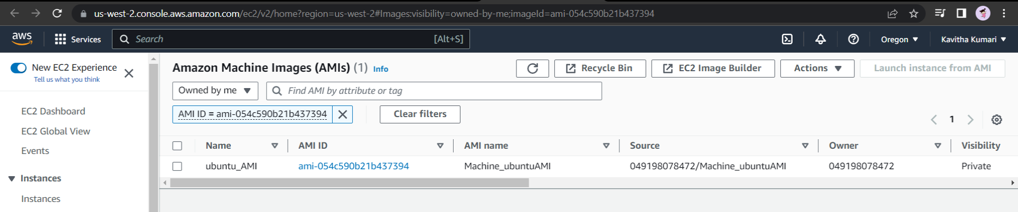

* Therefore, the AMI is created in the Oregon region.
* Now the next step is to launch an instance in the Oregon region with the AMI we created.
* To create an instance, select the AMI and click on **Launch instance from AMI**.
* Allow HTTP and let everything be default and **Launch Instance.**
* 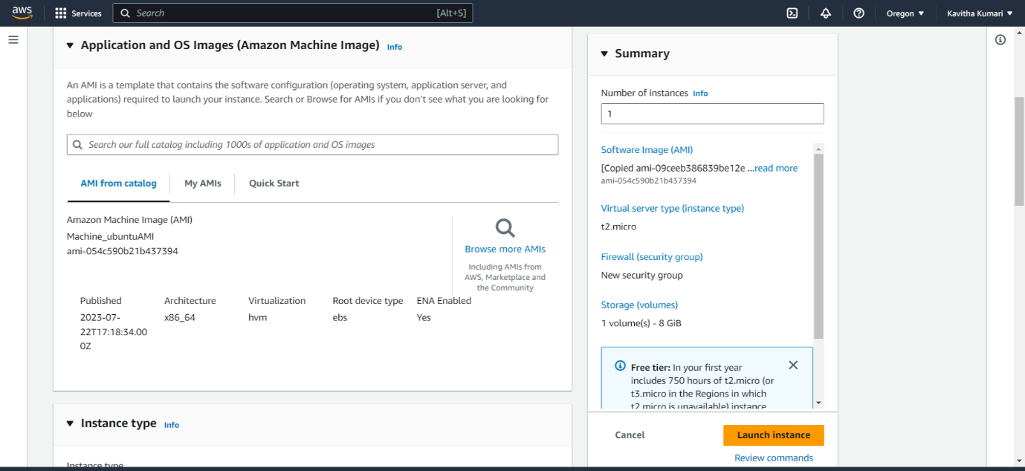Now if we copy the public IP of this instance search that in browser, we will see the default apache2 web page.
* Now we need to build 2 EBS volume and attach them to the instance of the **Ohio** region.
* **Note:** The volumes which we create must be in the same region. That is in **us-east-2a.**
* Navigate to the Elastic Block Store and click on voumes. Then click on **create volume.**
* Select the size and 1 and every thing be default and click on **create volume.**
* Similarly create another volume.

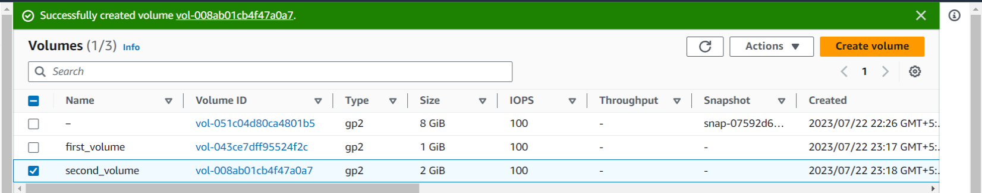

* 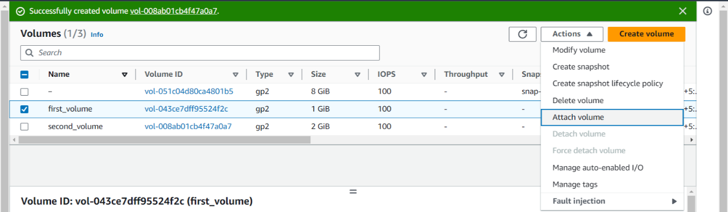Once both the Volume_state goes to available we can attach it to the instance.

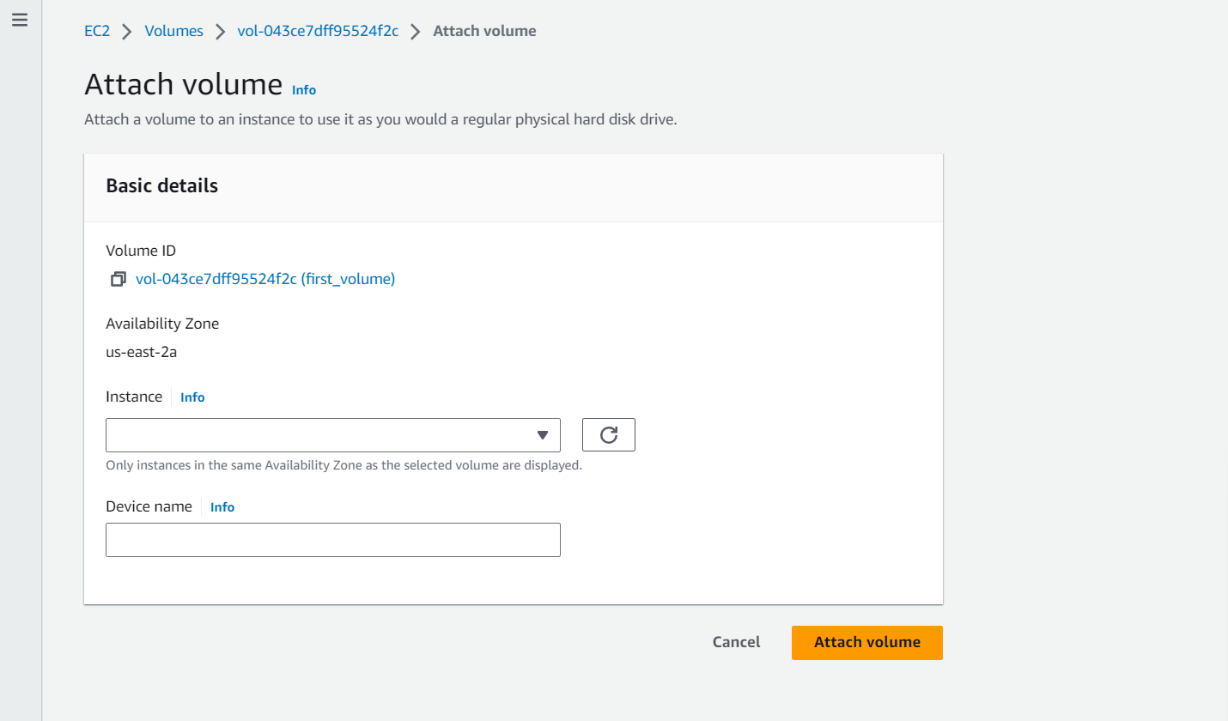

* Select the instance and click on **Attach Volume.**
* Similarly, we need to attach another volume.

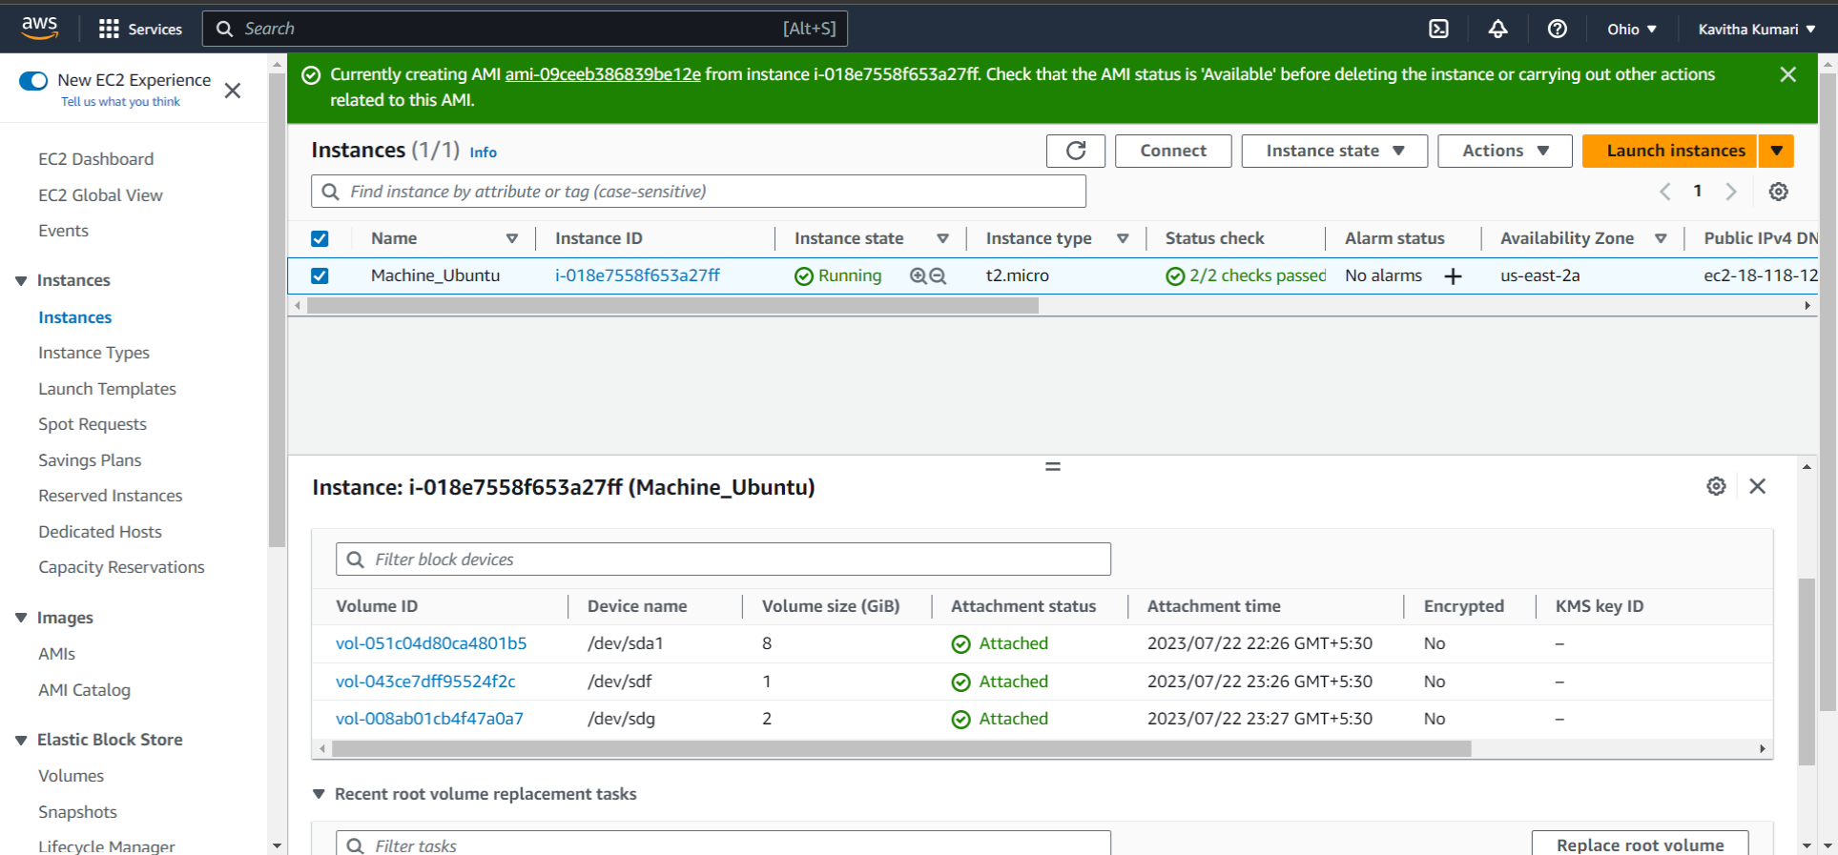

* To delete an EBS volume we need to first detach it and delete it.
* Select the volume and go to action and click on detach volume.

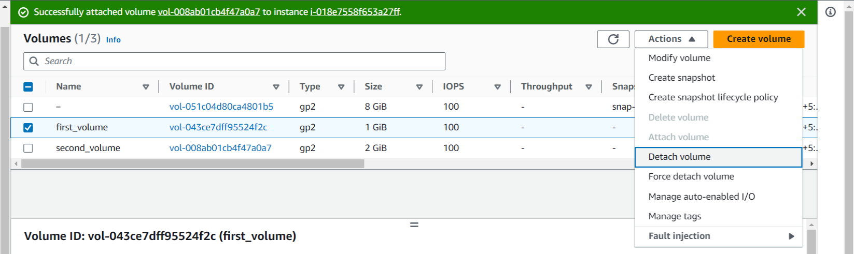

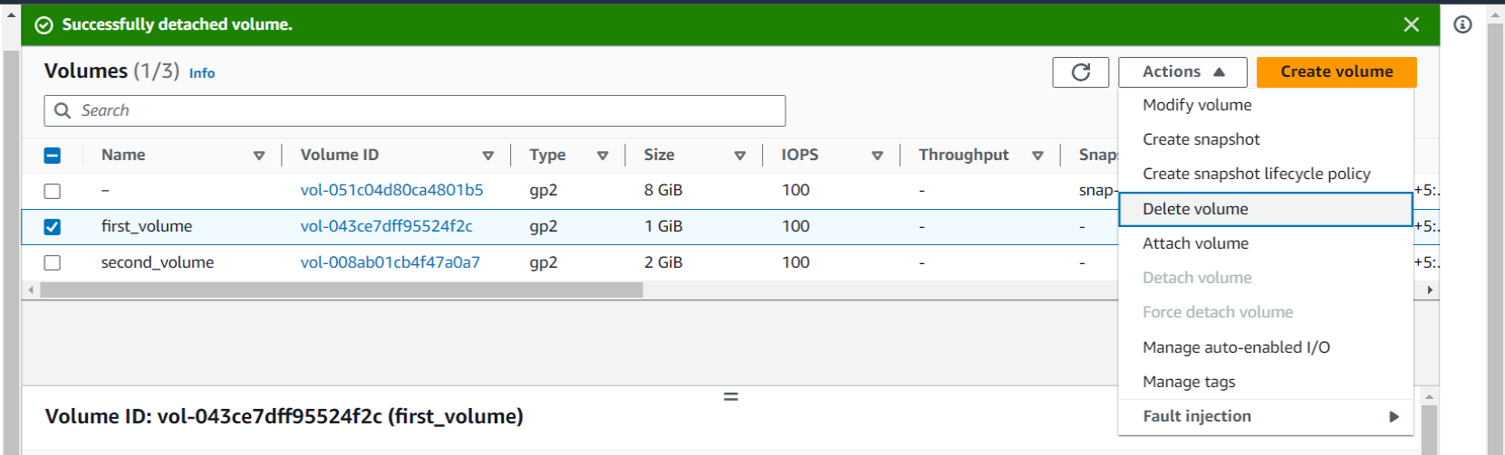

* Now we need to increase the size of the volume.
* Select the volume and go to actions there you will find the option of **Modify volume** click on that and then you can modify the volume.
* **Note:** You can only increase the volume but not decrease.

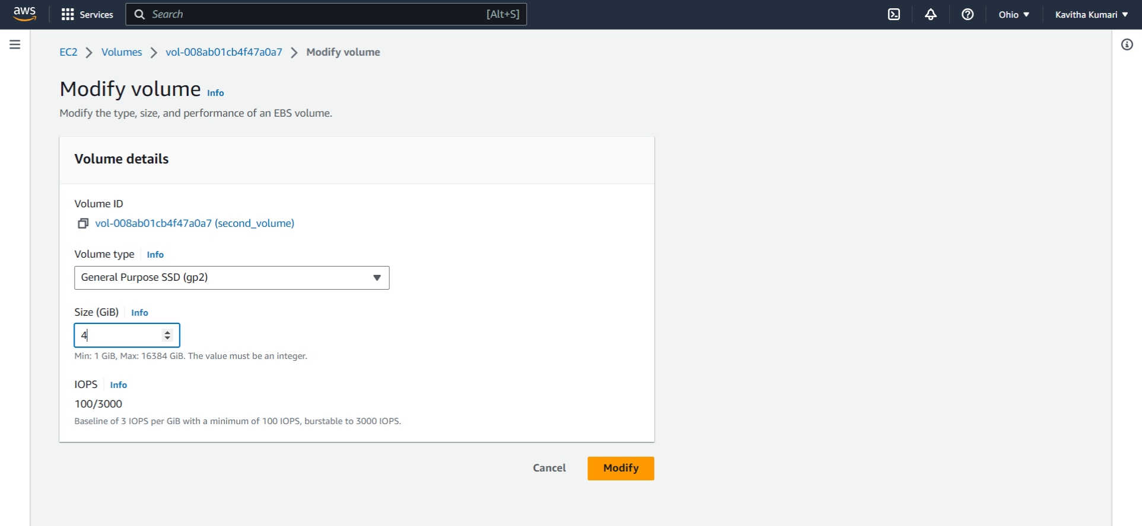

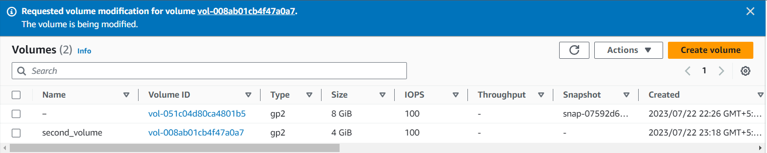

* Therefore, the volume has changed to the 4 GiB.
* Now we need to **format and Mount the** EBS volume which we have created.
* This can be done with the help you the Terminal of the instance. Run the following command.
* lsblk (It list out all the block level storage)
* sudo file -s /dev/xvda (here we are checking whther the root volume is being formatted or not)

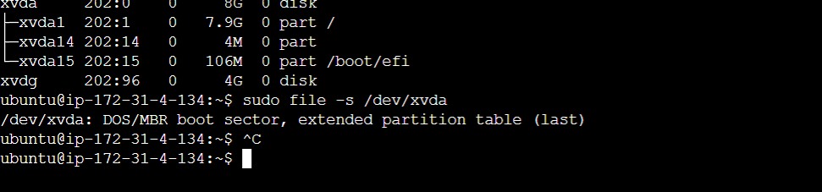

* The above statement means it has been formatted.
* sudo file -s /dev/xvdg (here we are checking whether the ebs volume is formatted on not.

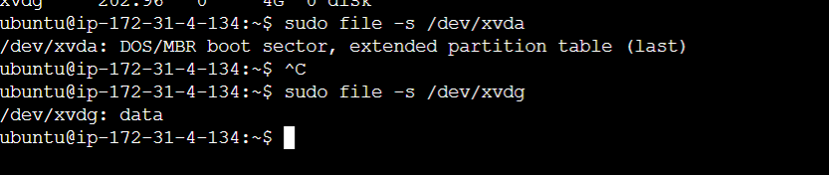

* It means the volume has been not formatted.
* sudo mkfs -t ext4 /dev/xvdg (here we are doing the format of the ebs volume attached seperately)



* Now we have to create the directory.
* sudo mkdir ebs (We created the directory named ebs)
* ls (it lists out the directories or files )

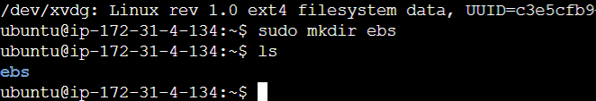

* sudo mount /dev/xvdg ebs (here we are mounting the particular volume to the ebs directory)
* Now if we run the command lsblk we will see the following output.

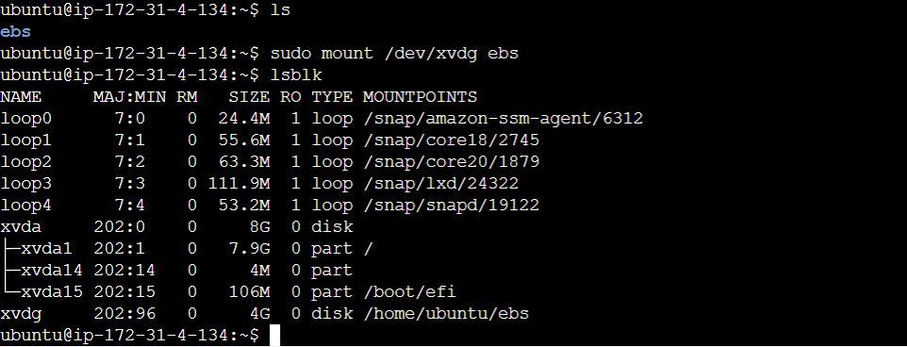

* Now we can create the files in the ebs volume.

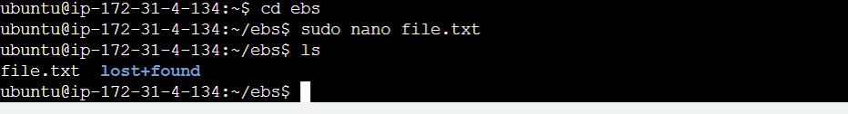

* cd (to exit the directory)
* To unmount the directory, we can run the following command.
* sudo umount /dev/xvdg
* Now we need to take the back ups of the ebs volumes.
* To take the backup select the volume and go to the actions and from there click on **create snapshot.**

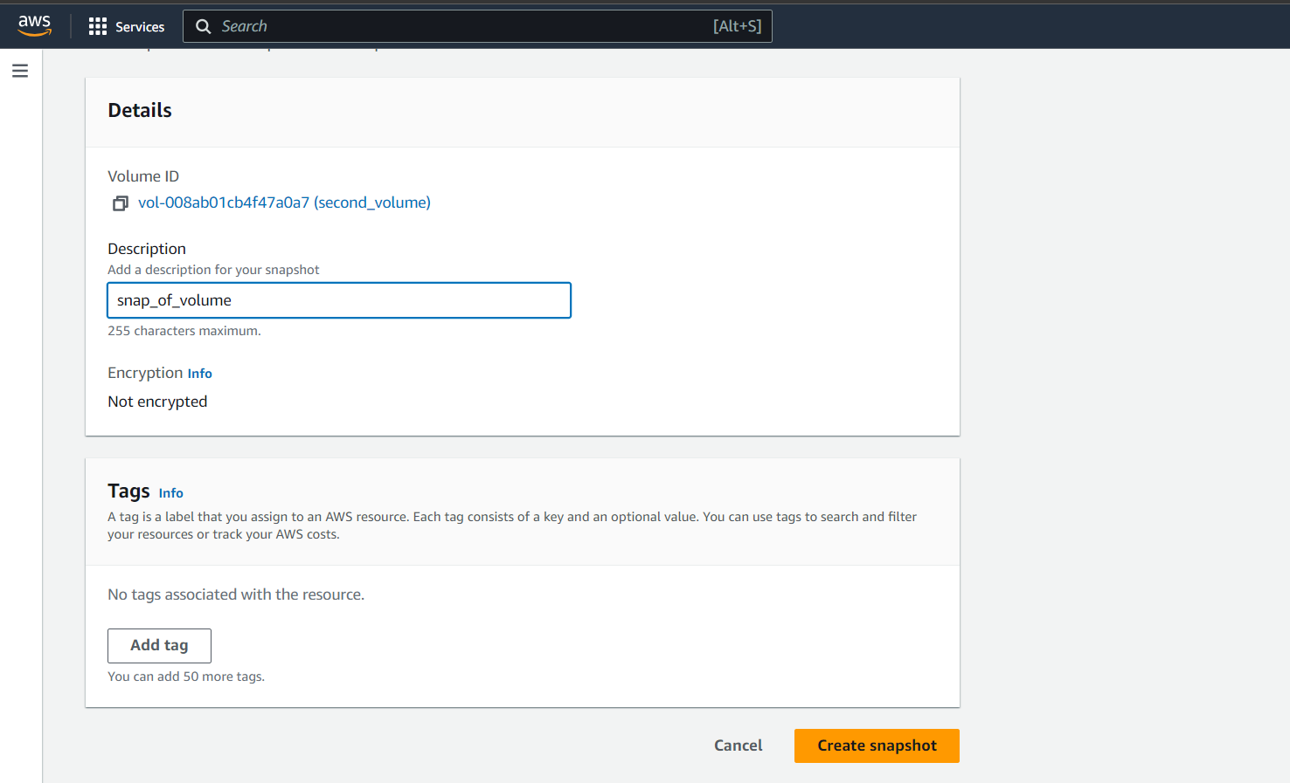

* To check the snapshots, navigate to the snapshots and there you will see the snapshots available

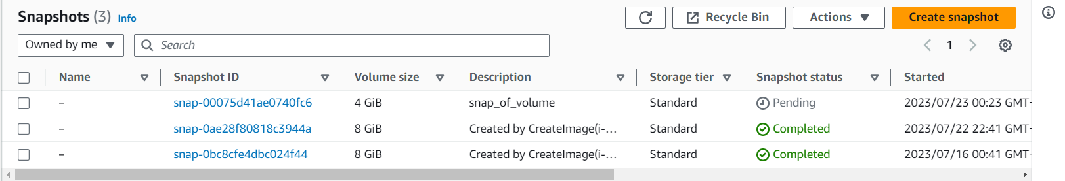

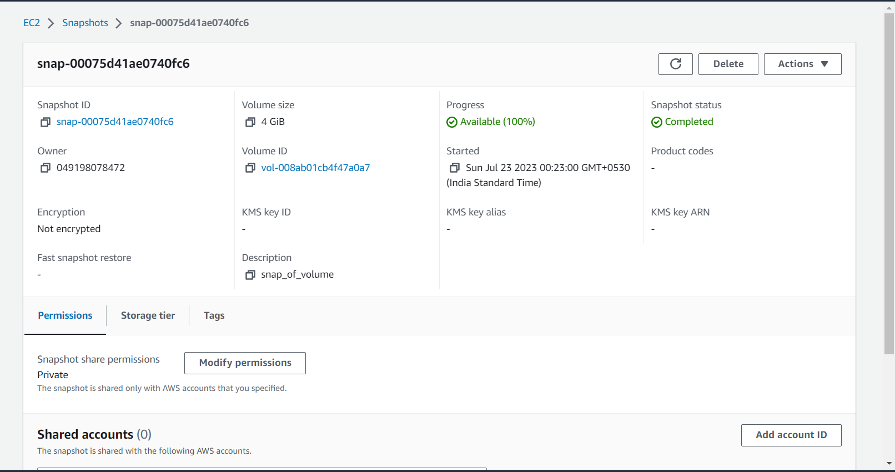

* From here we can copy the snapshot to the another region named Oregon and create the volume from the snapshot and attach to the instance.

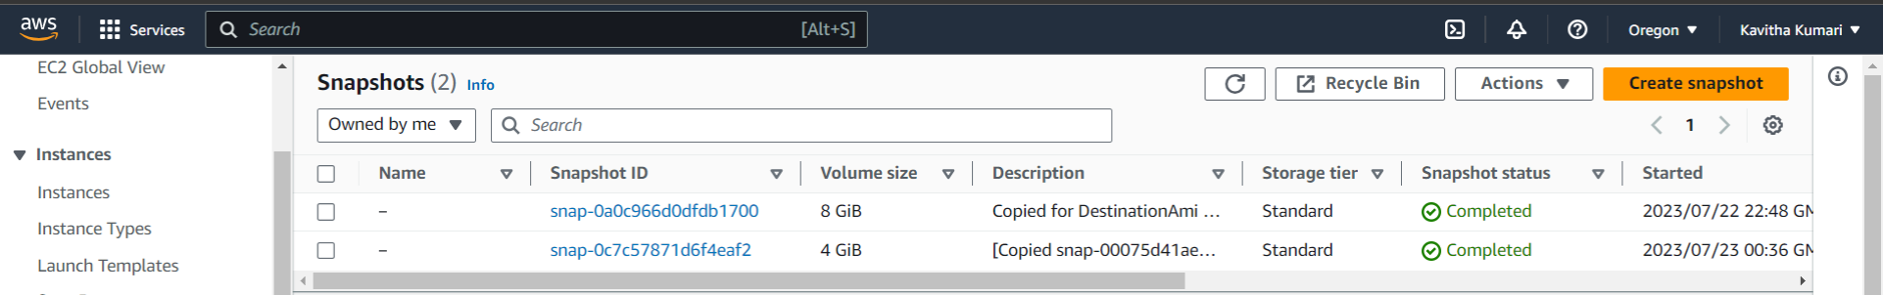

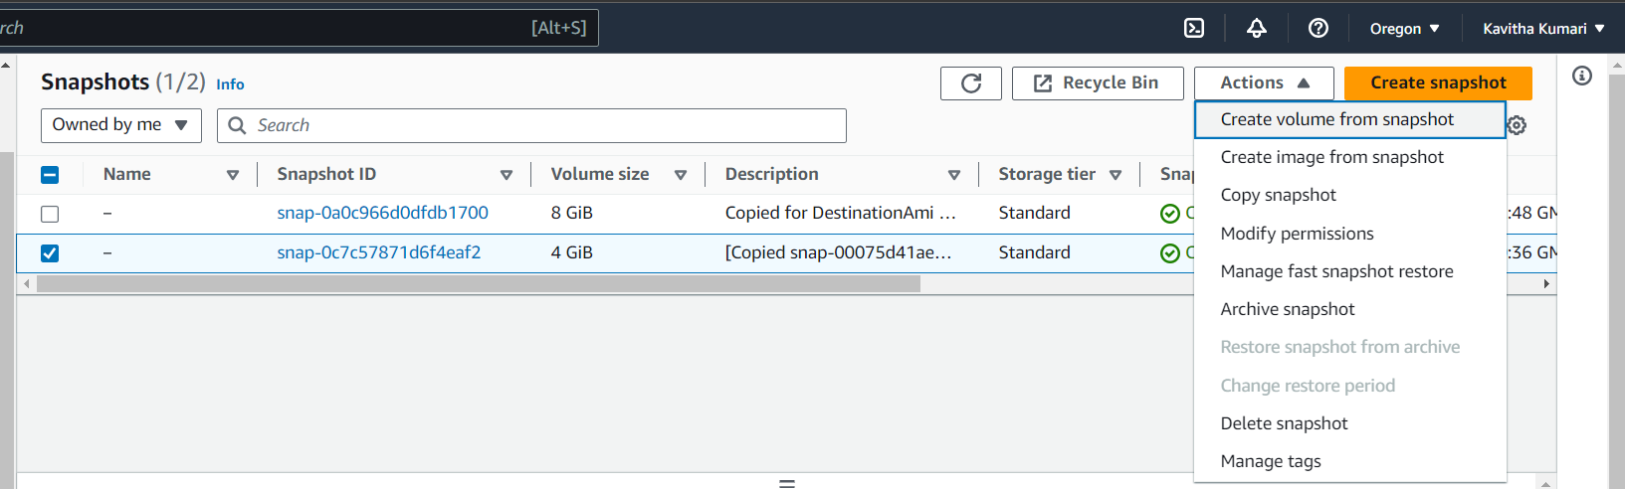

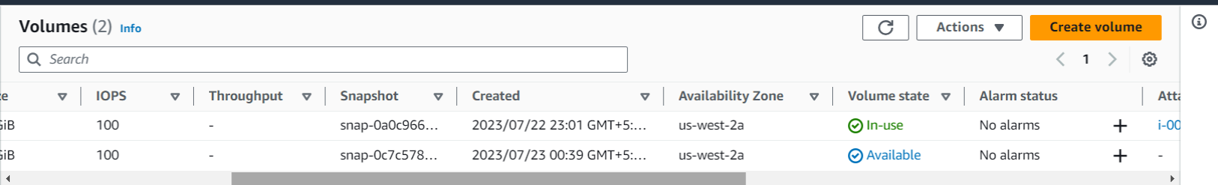

* Attach the volume to the instance which we created in the Oregon region.
* After attaching we need to connect our instance to the terminal. Then run the following command.
* sudo apt-get update
* lsblk
* sudo file -s /dev/xvdf (to check whether it is mounted or not)
* sudo mkdir ebs
* sudo mount /dev/xvdf ebs
* now if we run lsblk we will see that it is sucessfully avilable.
* cd ebs
* ls
* we will see the file file.txt
* sudo cat file.txt (to see the content of the file)

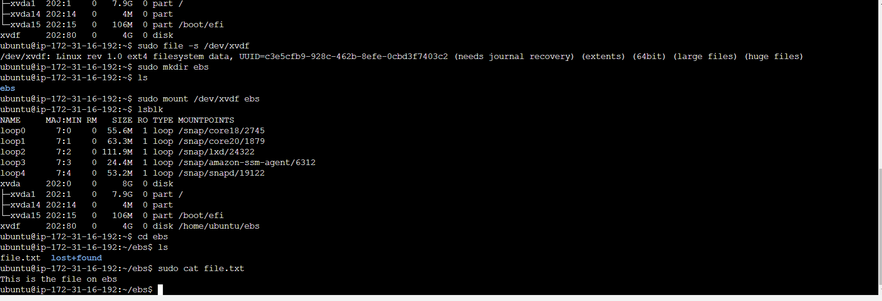

---------**END**---------